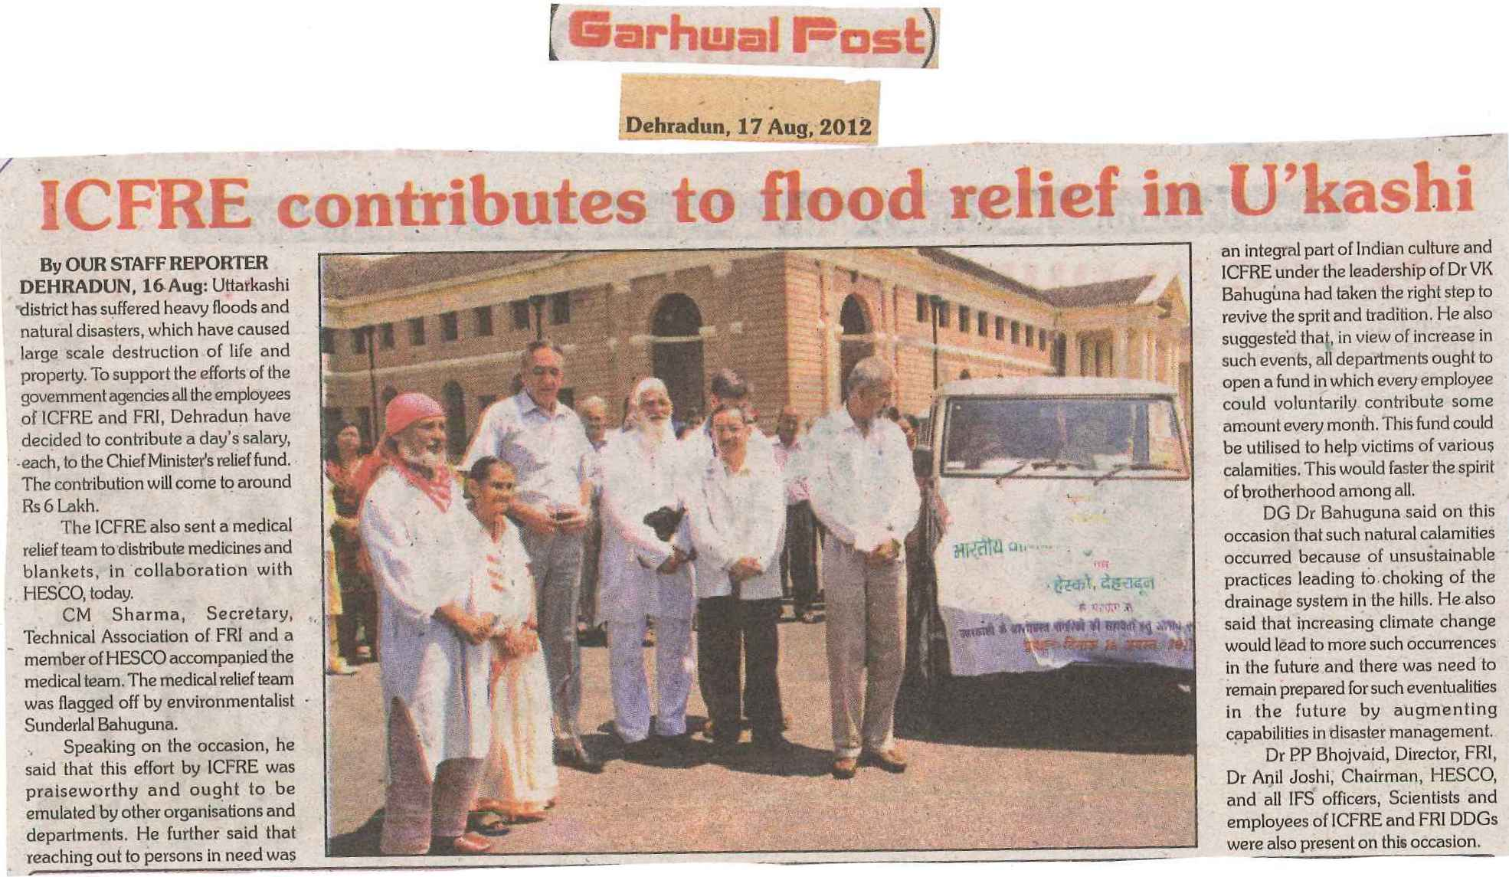

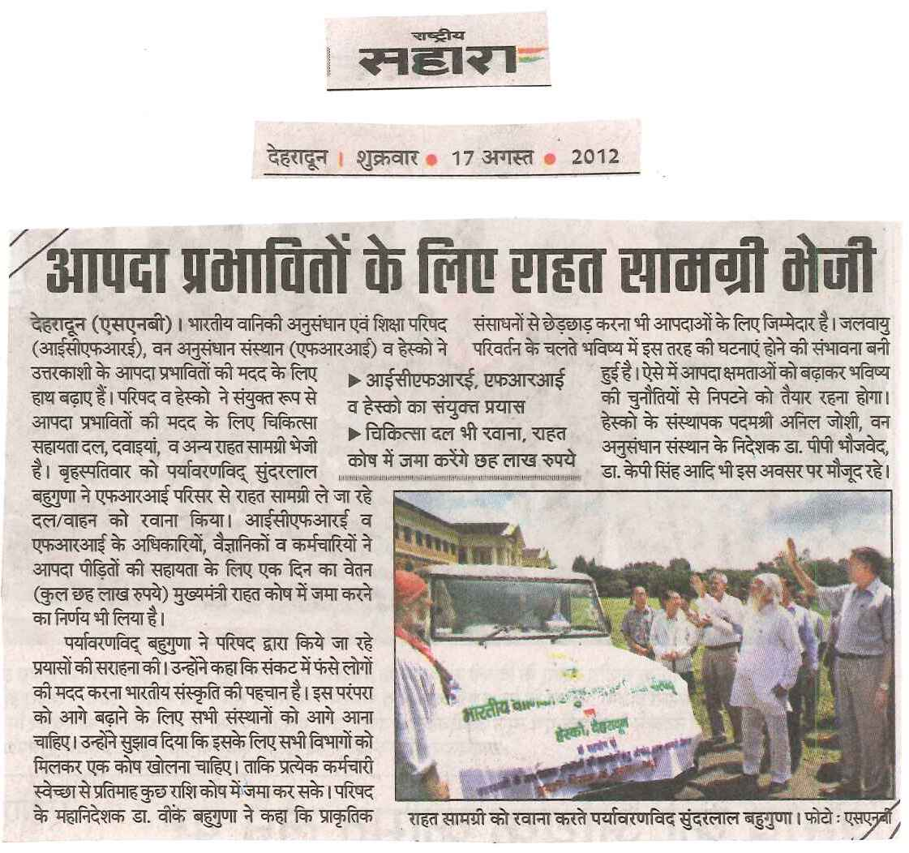

C:\Documents and Settings\Administrator\Desktop\new paper clippings\flood relief uttarkashi_0003.tif



C:\Documents and Settings\Administrator\Desktop\new paper clippings\flood relief uttarkashi_0005.tifC:\Documents and Settings\Administrator\Desktop\new paper clippings\flood relief uttarkashi_0006.tif

C:\Documents and Settings\Administrator\Desktop\new paper clippings\flood relief uttarkashi_0007.tif

