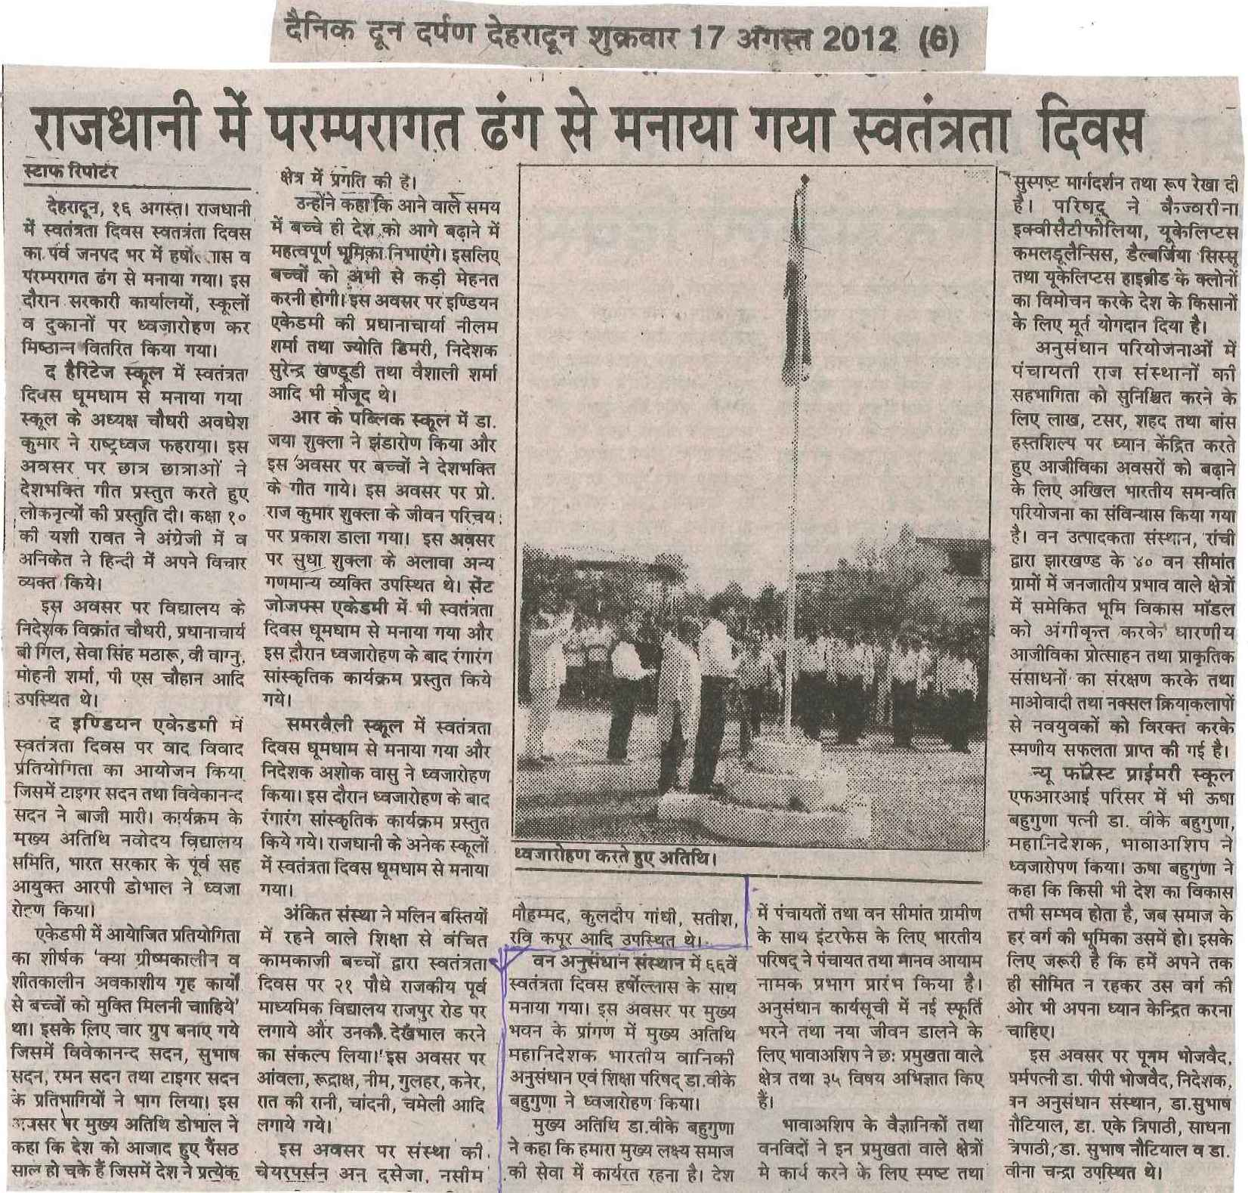

C:\Documents and Settings\Administrator\Desktop\new paper clippings\independence day celebration 2012_0002.tif



