GARHWAL POST, 16th March, 2012

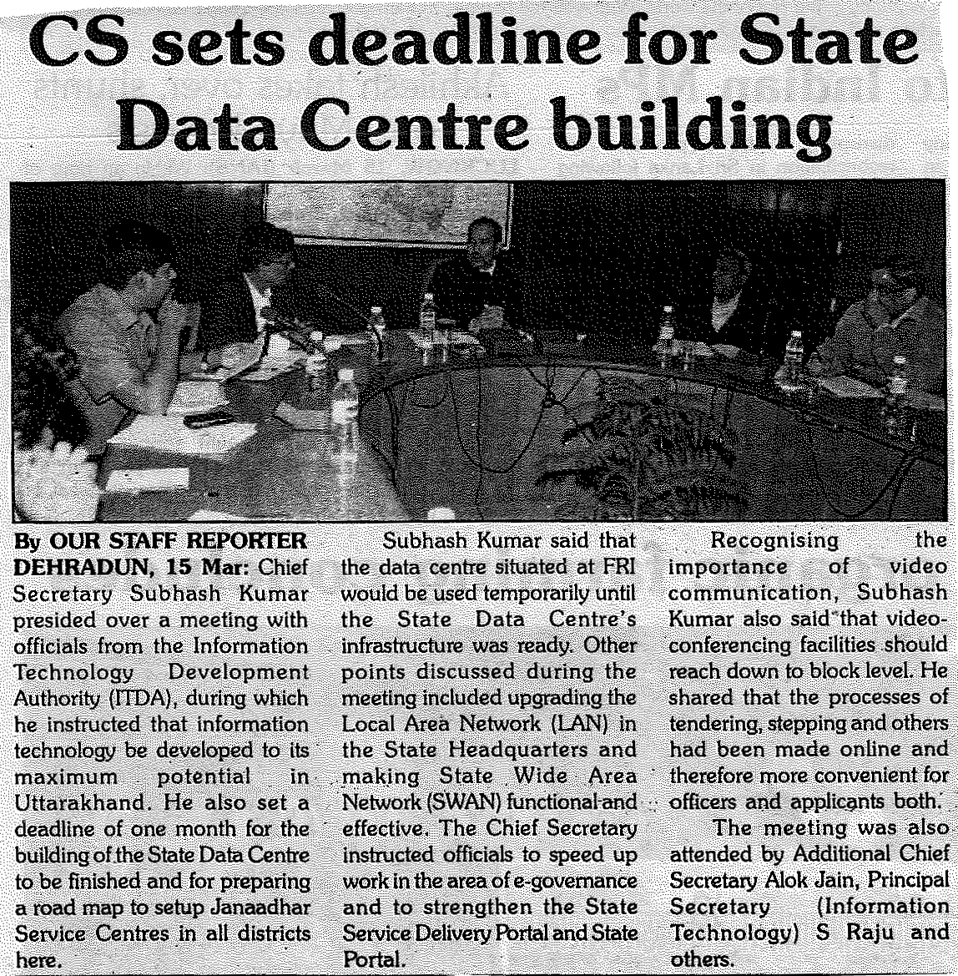

Dainik Jagran, 16th March, 2012



