Research Advisory Group Meeting for 2010 of ICFRE Institutes to decide on the new Forestry Research Proposals starts with IFGTB Coimbatore

Research Advisory Group Meeting 2010
Institute of Forest Genetics and Tree Breeding
Coimbatore
12. 10. 2010 &13.10.2010

The Research Advisory Group Meeting of the Institute for the Year 2011-12 was held at the institute at 9.30 am on 12.10.2010. It was presided by Shri. A. S. Balanathan, IFS, Principal Chief Conservator of Forests and Head of Forest Force, Tamil nadu. Dr. N. Krishnakumar, Director, IFGTB welcomed the gathering and mentioned that the projects presented for the approval of RAG is crystallized based on the themes or problems that emanated out of the series of Stake holders meetings arranged by the Institute with State Forest Departments, farmers and paper based industries. The Director also highlighted the current research, education and extension activities of the Institute besides the achievements and future programmes. Shri. T. P. Raghunath, Group Co-ordinator (Research), IFGTB briefed about the completed, ongoing research projects and the 23 newly proposed projects. He also described about the scoring procedures for the new projects.

Shri Ashish Rawat, ADG (Research Planning), ICFRE in his remarks mentioned that IFGTB is the leading Institute under ICFRE. He underlined the role of RAG in examining the new projects proposed based on the regional requirements as well as to bring innovation in research. He also stressed on the message conveyed by Dr. G.S. Rawat, Director General, ICFRE on the balance that is to be maintained during assessment of ICFRE Forestry Research Priority themes, utilization of material (equipments), field and lab works, manpower and the financial aspects of the projects along with the referee's comments while scoring by the RAG members. Also priority to state forest department research needs may be given when taking up new research proposals.

Shri K Ravichandran, DCF and Extension Officer, IFGTB said that to meet the stakeholder demands the Institute is bringing out series of publications based on the research results and informed the relevance and use of the new publications brought out during RAG. The RAG Chairman, Shri. A. S. Balanathan, IFS, PCCF released the following publications.

- Hand Book on Insect pests of Forest Tree Species by R. Rajarishi. A. Balu and R. Mahalakshmi was received by Dr. Shivaraju, CCF (Work Planning Research), Kerala Forest Department.
- Poster on Pest Calendar and IPM in Forest Nurseries by John Prasanth Jacob was received by Shri. Srinivasamurthy, Director, Department of Environment.
- Poster on Biofertilizers for Enhanced Productivity of Forest Trees by V. Mohan was received by Shri. Asish Rawath ADG, Research Planning, ICFRE.
- Brochure on Gass Forest Museum was received by Dr. Ajay Baldeva, Century Plywood Limited
- Van Vigyan Newsletter of IFGTB was received by Dr. K. V. Sankaran, Director, Kerala Forest Research Institute, Peechi.

Chairman of the RAG 2010, Shri. A. S. Balanathan, IFS, PCCF, Tamil nadu expressed his pleasure in participating in the RAG meeting of IFGTB. He presented the general forest scenario in the country particularly in Tamil nadu. He recalled that the forest management in India is very old and is one of the pioneering departments in the entire world with long history and legacy. Forest policies have undergone considerable change from police oriented strategy to production oriented forestry and now to people oriented forestry. Forest policy of 1988 of Government of India is in place and this is the base of all the programmes of Forest departments and Research Institutes of the country. With the passing of the Forest Right Act, serious discussions are going on in the Government of India to redefine the role of Forest Departments. Ministry of Environment and Forests and the Tribal Welfare Ministry (GoI) are in discussions regarding providing power to the tribals living in the forests in forest management. He mentioned the decision taken by the Govt. of India to launch of dedicated satellite to monitor the forest cover of the country. In this context support of research institutes to forest managers is very vital. Forest departments also have research wings. But due to inadequate staff and infrastructure full fledged research could not be taken up. Research Institutes like IFGTB are in a better position to concentrate only on research and cater to the research needs of the region and the results obtained could be directly passed on to the forest managers and other stake holders like farmers. Tamil nadu Government has initiated a programme called Tree Cultivation in Private Land (TCPL) since 2007 and farmers are showing interest. He stressed that recommending tree species matching to the geographic region or soil as per the market demand is very important. Ultimately tree cover has to be improved. He suggested that instead of working more on exotic species more indigenous species should be studied and only if inevitable exotic species be taken up for study.

The Chairman congratulated the excellent works carried out by the Director and team of Scientists of IFGTB and expressed his happiness on the fact that IFGTB is the leading Institute under ICFRE. He also wished that more useful results for the end users will be generated from this institute in future.

The presentations on the 23 new projects proposed were made in the RAG 2010 of IFGTB.

The second day proceedings on 13.10.2010 were started at 9.30 am and the progress on all the ongoing research projects of IFGTB was discussed.

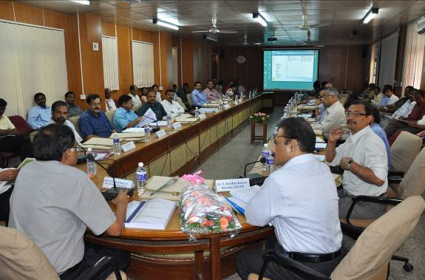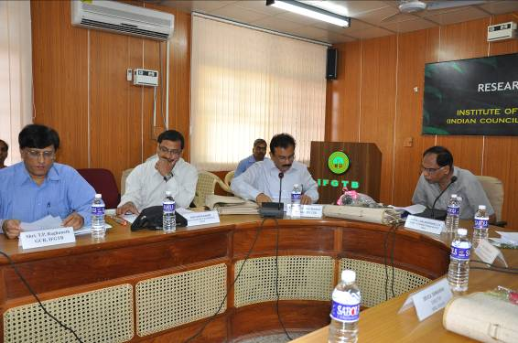
RAG 2010 Meeting Welcome address and overview on the research activities of IFGTB by the Director
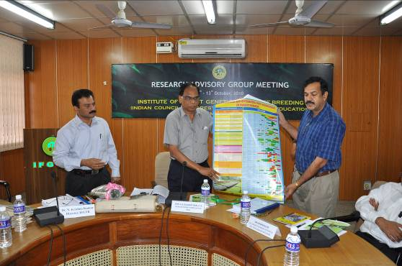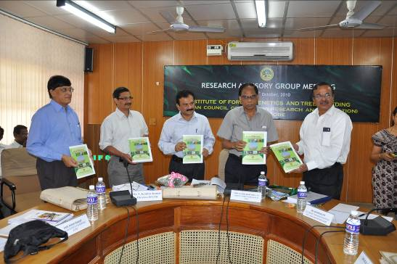
Release of Poster on Pest Calendar Release of Hand Book on Insect pests of Forest Tree Species

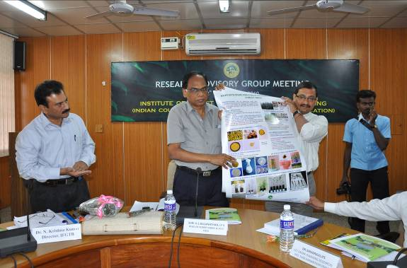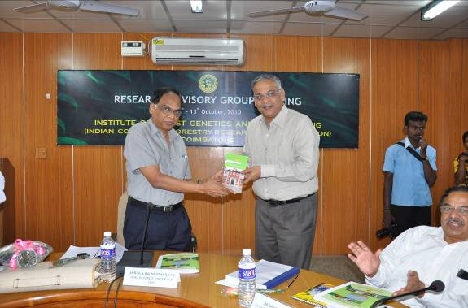
Release of Poster on Biofertilizer Release of brochure on Gass Forest Museum

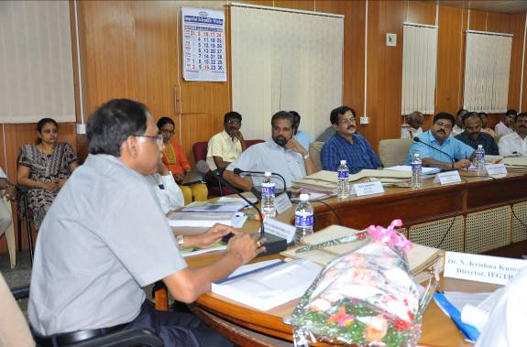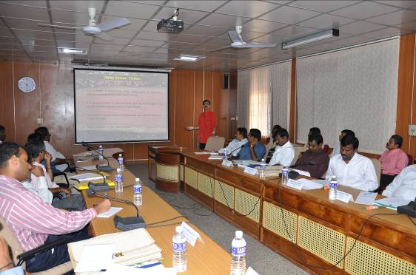

Chairman, RAG 2010 addressing the gathering Presentation on New research projects

Press Reports on RAG Meeting 2010 at IFGTB



